Not so Artificial

-Aishwarya Kaul

CSE 2nd year

BVCOE

Artificial intelligence, the term was coined by John McCarthy in 1955 and he defined it as “The science and engineering of making intelligent machines”. We all have seen the famous cartoon series ‘The Jetsons’, the movie ‘I, Robot’, the terminator in ‘Terminator’ , Frankenstein and innumerable other inhuman characters who are highly intelligent and as capable as humans, if not more. It was then, just a wild imagination. But who knew, they would actually come to life one day!

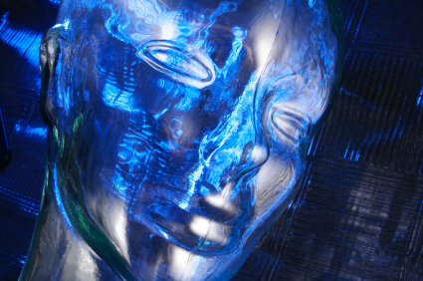

Today, many of the gadgets we use contain features enabled due to artificial intelligence. The online shopping assistants, voice recognition and motion detection in mobile phones are all wonders of artificial intelligence. Robotic surgeries, robot pets like the AIBO, Kismet and the chess playing robot ‘Deep Blue’ are just a few of the miracles of artificial intelligence.

The thought of artificial beings originated from the idea that the ‘sapience’ of humans can be replicated precisely into a machine. Some scientists believe that the brain is nothing but a computer, which completely devalues humans and also raises ethical and philosophical issues. But it is nevertheless a matter of great optimism.

It all started with the invention of programmable digital electronic computer based on the works of Alan Turing. After its success a few scientists started considering creating an electronic brain (cloning). John McCarthy, Marvin Minsky, Allen Newell, Herbert Simon and their students designed algorithms that stunned the world. They could solve word problems algebraically, prove logical theorems and even speak English. But this was followed by a decline in research called the AI Winter due to pressure from the US Government to fund more productive research. AI revived again in the 21st century with its usage in data mining, logistics and many other fields. One of the main research areas of AI is artificial neural networks which is an interconnection of nodes similar to the neurons in our brain.

An intelligent system is expected to be able to deduce reason and solve problems. It has to be able to deal with uncertainties and still be able to choose the best solution (optimization). Knowledge representation in an AI system is highly necessary including default reasoning and commonsense knowledge. They must be able to plan, set goals, achieve them and at the same time learn with experience (self improvement) just like humans! They must be equipped with language processors, motion detectors, perception (computer vision, speech recognition) and social intelligence. Efforts have also been made to enable artificial beings to sense emotions and if not feel them, but at least display them.

There is no one particular logic or theory for AI Research. Many researchers feel that artificial intelligence can be improved by studying the human brain and its psychology but some feel that it is “as irrelevant as bird biology to an aeronautical engineer”. There are many approaches like cognitive simulation, anti-logic and the search is on.

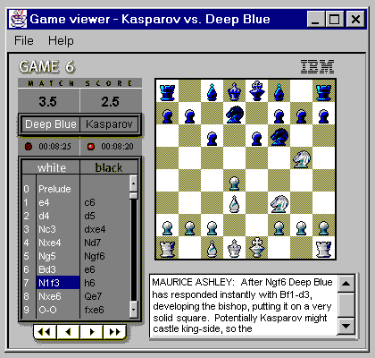Today AI is advanced to such a level that Deep Blue defeated World Chess Champion Garry Kasparov. In 2005, a robot by Stanford won DARPA Grand Challenge by driving autonomously for 131 miles. IBM’s question answering system defeated Jeopardy champions Brad Rutter and Ken Jennings. The all favorite Kinect used in Xbox 360 and IPhone’s Siri are also intelligent systems.

The development of artificial intelligence excites each and every one of us but also poses certain threats. The low wage entry level workers might get replaced by robots hence reducing employment. Also, AI systems are not emphatic hence cannot replace human customer service or psychotherapy. Hans Moravec and a few others have predicted that in the future humans and robots will merge to form cyborgs that will be more capable than either of the two. But, Charles T. Rubin argues that it is not necessary that robots will be friendly to humans. An instance of this is from the movie ‘I, Robot’ in which the computer brain ultimately tries to take control over humans, but we all wish against such a catastrophe!

Hence it is very important that this research is carried out in a controlled and ethical manner, without causing harm to humans and their ethics and philosophy! Artificial intelligence is indeed the next stage in evolution and might soon become the driver of technological singularity. Darwin might have never even thought of that!